Ques1:- Write an HTML program to produce the registration form shown below, then write JavaScript to validate it on submission. The script should check that every field — Name, Email, Password and Age has a value, display a clear inline message next to any field left blank, and prevent the form from submitting until all fields are filled.

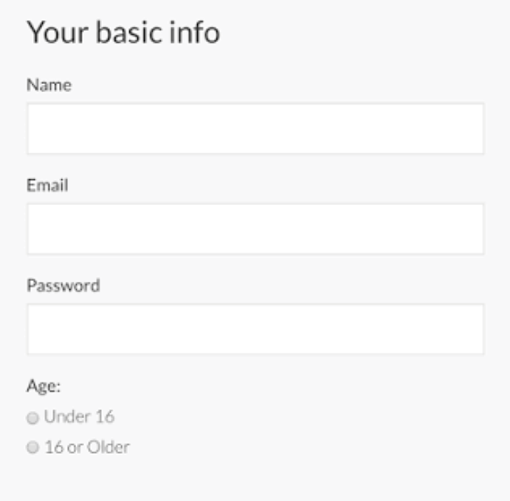

Ques 2: Create an image slider (carousel) using JavaScript that displays images one at a time, with Previous and Next buttons for navigation. To keep the browsing experience smooth and continuous, the slider should loop back to the first image after reaching the last one (and vice versa).

Ques 3: Write a program to calculate the factorial of a number using a loop.

Ques 4: Write a program to count how many numbers between 1 and 100 are divisible by 5.

Ques 5: Write a program to find the sum of digits of a given number.
Ex: 123 -> 6
Ques 6: Given an array, write a program to find the largest and smallest element using a loop.

Ques 7: Given an array, count how many times a particular number occurs.

Ques 8: Given an array of numbers, create a new array containing only the even numbers using a loop.

Ques 9: Write a program to count the frequency of each element in an array.

Ques 10: Write a program to merge two arrays without duplicate elements.

